Exercise 7-3 Age classification

Jirayu Petchhan, D10907801

From Main_Angular.py

Setting the method of cost function

Changing to age DS.

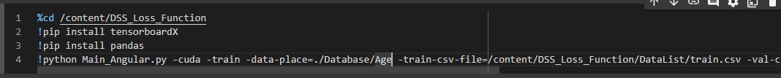

Changing to Angle Loss

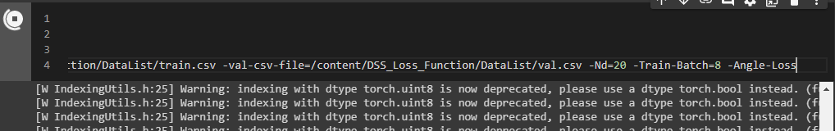

Performance (Angle-Loss)

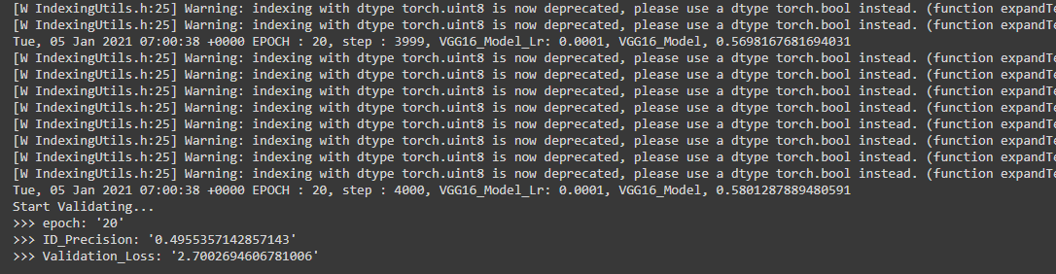

Snapshot path to use into feature compare



Feature comparation testing (based on Angle Loss)

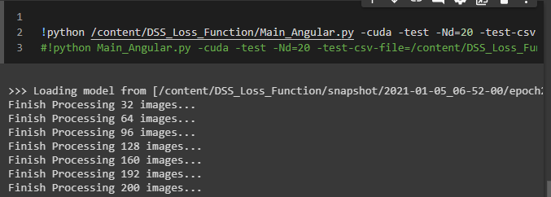

Changing path to test in feature_compare.py

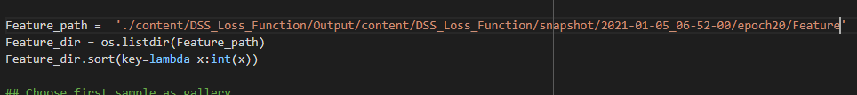

Accuracy (Euclidean)

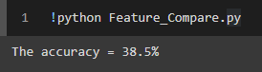

Accuracy (Cosine)

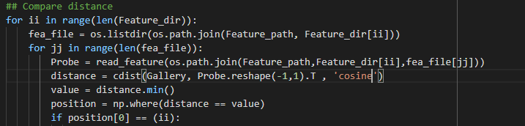

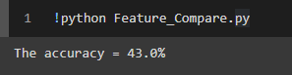

Result

The accuracy got from Euclidean is less than accuracy from Cosine method that is the same as test in 7-2 (CASIA_Data).